Create authentication service that returns JWT

**Solution:**

**Step 1**: **Adding Maven dependency** for **JWT** in **pom.xml** file

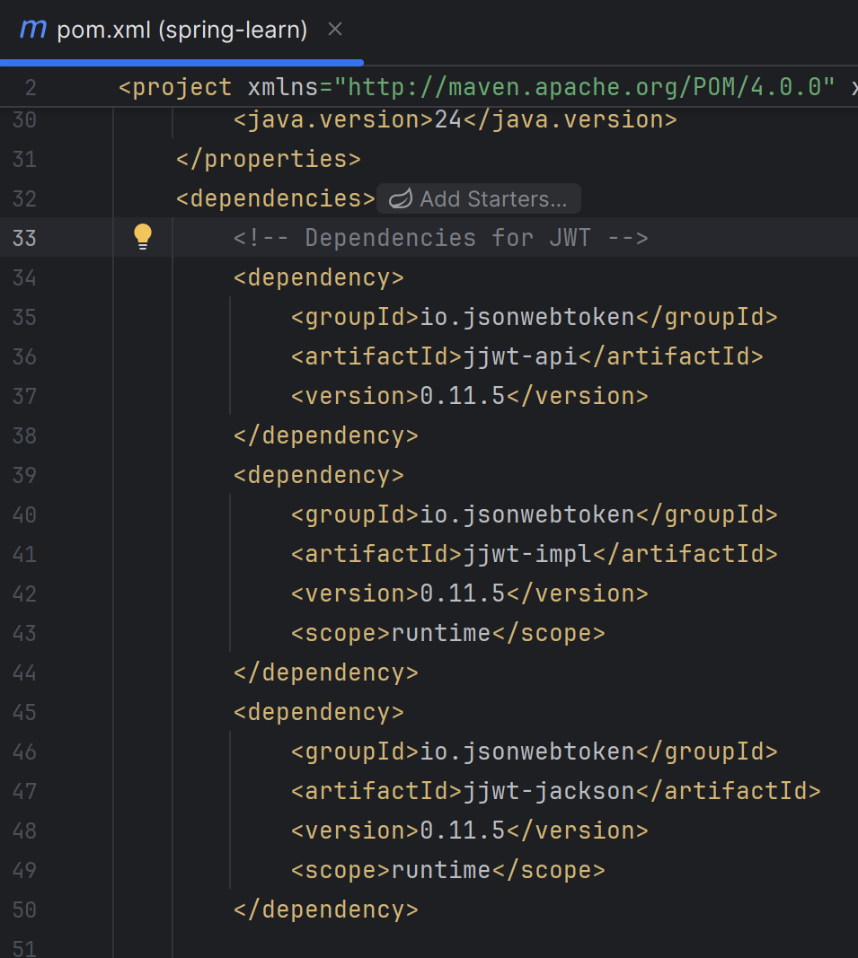

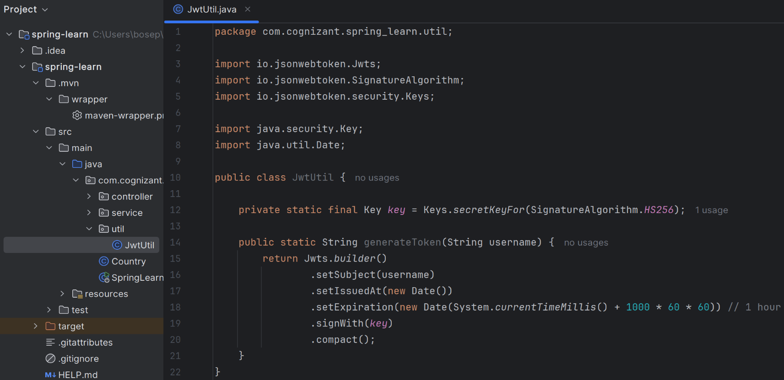**Step 2**: **Creating** **JwtUtil** class to **generate token** in new package named “util” under the main folder under src in the project structure.

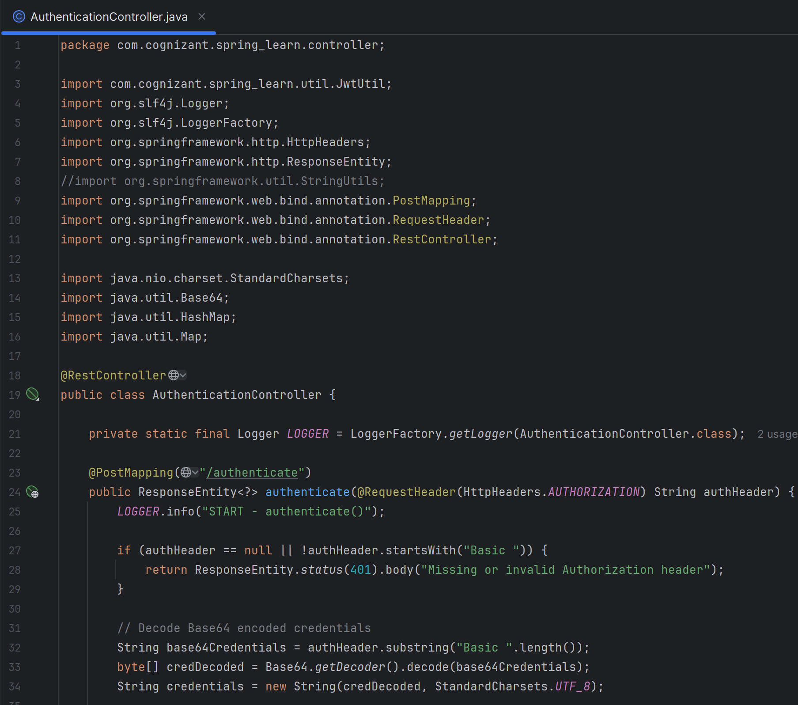-Here in this class, we keep a simple **secret-key** in memory for demo purpose. **Step 3**: Creating **AuthenticationController** class under “controller” package.

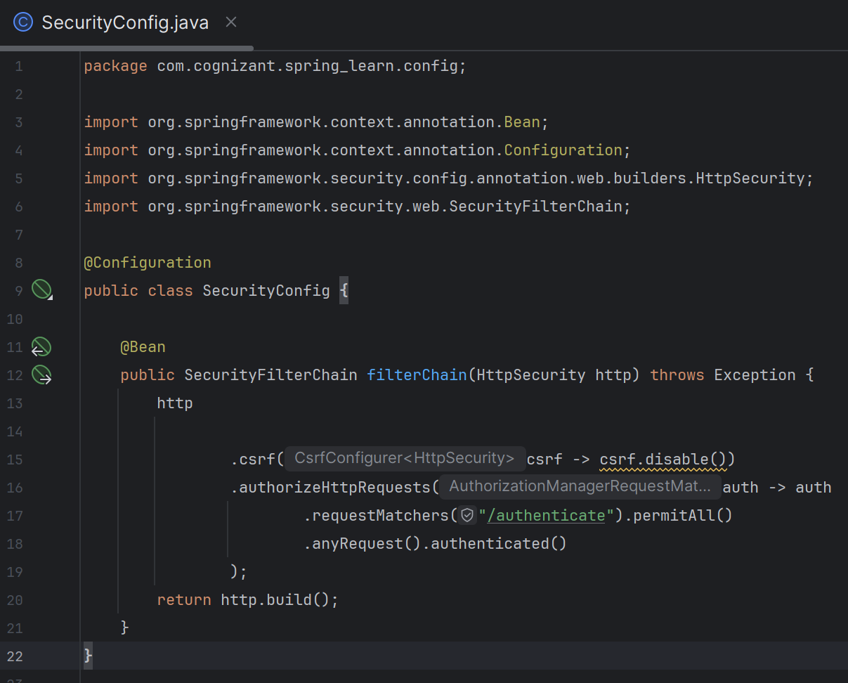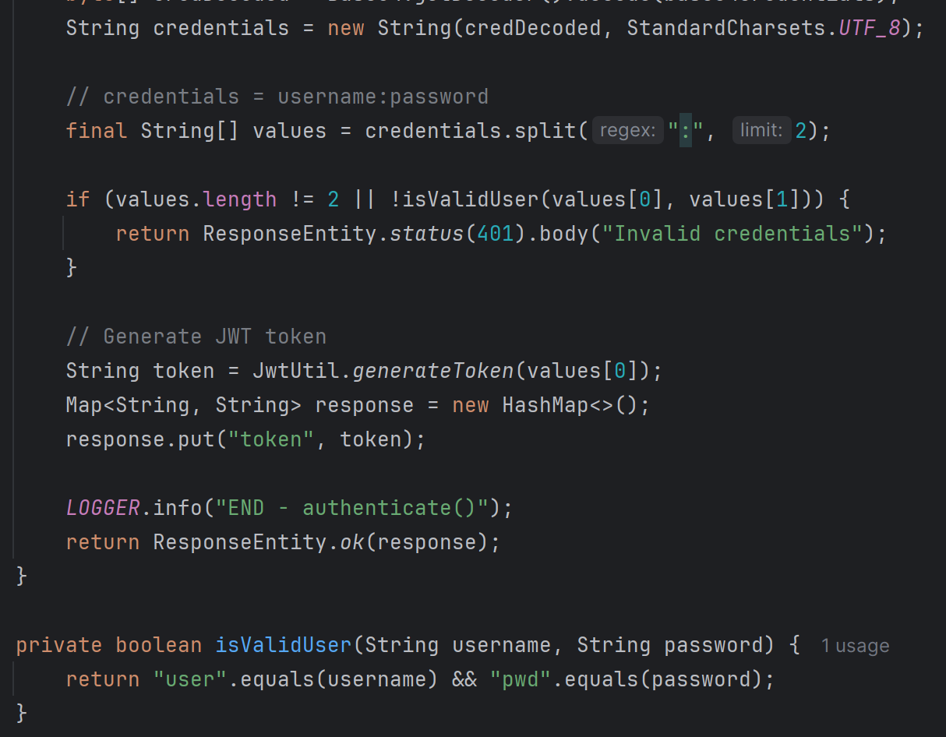**Step 4**: **Configuring security** to allow **/authenticate :** creating a **SecurityConfig.java** class under a new package “config” in the main folder of src.

The above config class allows **/authenticate** to be accessed without authentication.

**Step 5**. Test with **curl :** I was facinga sea of errors while testing with curl on the terminal or cmd so I ran **basic auth-test** on **Postman** & the output i.e. the secret-token is depicted below:

Log output :



-the above log-report depicts that the **/authenticate** ***endpoint was hit, and completed.***

***\*\*\*\*\*\*\*\*\*\*\*\*\*\*\*\*\*\*\*\*\*\*\*\*\*\*\*\*\*\*\*\*\*\*\*\*\*\*\*\*\*\*\*\*\*\*\*\*\*\*\*\*\*\*\*\*\*\*\*\*\*\****

